8 Sep 2024

Theme: Christ our Centre (Eph 5:22-6:9)

Song 1 - All Hail the Power of Jesus' Name

Song 2 - Christ Be Magnified

Kids' Song - W-I-S-D-O-M

Song 3 - Speak O Lord

Closing Song - Turn Your Eyes

8 Sept Order of Service (for Service Sheets)
Welcome
Declaration - The Nicene Creed
Song 1 - All Hail the Power of Jesus' Name
Song 2 - Christ Be Magnified
Confession
Lord's Supper
Offering
Bible Reading - Isaiah 54:4-8
Prayer
Announcements
Kids' Song - W-I-S-D-O-M
Song 3 - Speak O Lord
Bible Reading - Ephesians 5:22-6:9
Sermon
Closing Song - Turn Your Eyes
Mutual Upbuilding

All hail the power of Jesus’s name

[Verse 1]
E B
All hail the pow'r of Jesus' name!
A E B E
Let angels prostrate fall;
E C#m
bring forth the royal diadem,
E B C#m B F# B
and crown him Lord of all;
E B
bring forth the royal diadem,
E A E B E
and crown him Lord of all.

[Verse 2]
E B
Ye chosen seed of Israel's race,
A E B E
Ye ransomed from the fall.
E C#m
hail him who saves you by his grace,
E B C#m B F# B
and crown him Lord of all;
E B
hail him who saves you by his grace,
E A E B E
and crown him Lord of all.

[Verse 3]
E B
Let ev'ry kindred, ev'ry tribe,
A E B E
on this terrestrial ball,
E C#m
to him all majesty ascribe,
E B C#m B F# B
and crown him Lord of all;
E B
to him all majesty ascribe,
A E B E
and crown him Lord of all.

[Verse 6]
E B
O that with yonder sacred throng
A E B E
we at his feet may fall!
E C#m
we'll join the everlasting song,
E B C#m B F# B
and crown him Lord of all;
E B
we'll join the everlasting song,
E A E B E
and crown him Lord of all.

Christ be Magnified (D)
[Intro]
D… A. Gadd9…. X2
[Verse 1]
D Gadd9
Were creation suddenly articulate
D Gadd9
With a thousand tongues to lift one cry
D/F# Gadd9
Then from north to south and east to west
Asus A D A Gadd9
We'd hear 'Christ be magnified!'

[Verse 2]
D Gadd9
Were the whole earth echoing His eminence
D Gadd9
His name would burst from sea and sky
D/F# Gadd9
From rivers to the mountain tops
Asus A D
We'd hear 'Christ be magnified!'

[Chorus]
D D2/E G
O! Christ be magnified!
A Bm
Let His praise arise
A G
Christ be magnified in me
D D2/E G
O! Christ be magnified!
A Bm
From the altar of my life
A G A D A Gadd9
Christ be magnified in me

[Verse 3]
D Gadd9
When every creature finds its inmost melody
D Gadd9
And every human heart its native cry
D/F# Gadd9
O then in one enraptured hymn of praise
Asus Gadd9
We'll sing 'Christ be magnified!'
Gadd9
O be lifted high, Jesus

CHORUS
G A Bm D/F#
[Bridge]
G
I won't bow to idols
A
I'll stand strong and worship You
Bm
And if it puts me in the fire
D/F#
I'll rejoice 'cause You're there too
G
I won't be formed by feelings
A
I hold fast to what is true
Bm
If the cross brings transformation
D/F#
Then I'll be crucified with You
G
'Cause death is just the doorway
A
Into resurrection life
Bm
And if I join You in Your suffering
D/F#
Then I'll join You when You rise
G
And when You return in glory
A
With all the angels and the saints
Bm
My heart will still be singing
A
And my song will be the same
CHORUS SOFT - Guitar
CHORUS LOUD

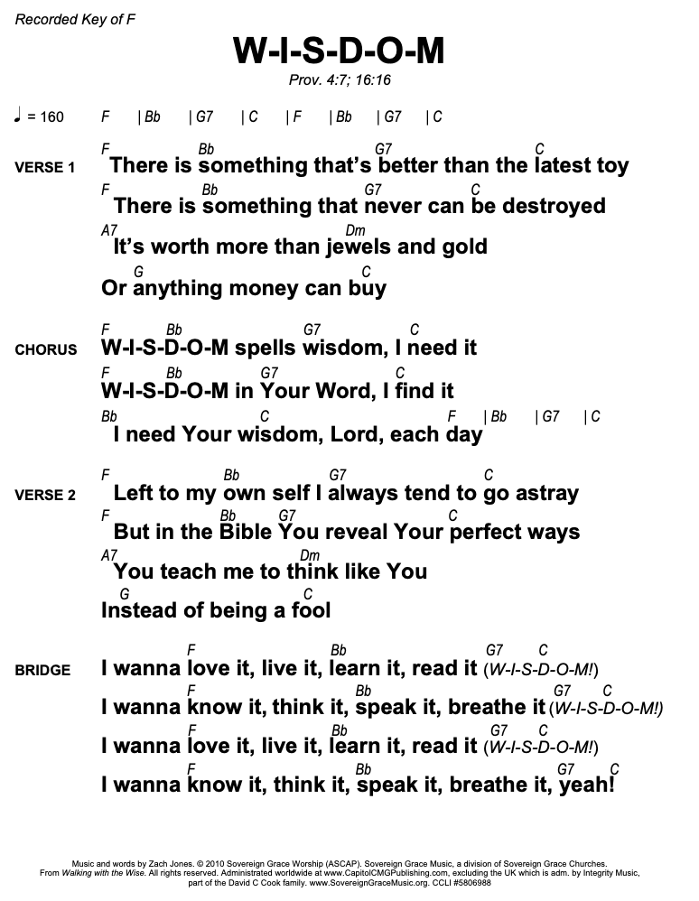
SPEAK O LORD

D E A D A/C#
Speak, O Lord, as we come to You
D A/C# F#m E
To receive the food of Your Holy Word.
D E A D A/C#
Take Your truth, plant it deep in us;
D A/C# E A
Shape and fashion us in Your likeness,
E E/D A/C# D A/C#
That the light of Christ might be seen today
E E/D A/C# D E
In our acts of love and our deeds of faith.
D E A D A/C#
Speak, O Lord, and fulfill in us
D A/C# E A
All Your purposes for Your glo ry.

Interlude
D E A D A/C#
Teach us, Lord, full obedience,
D A/C# F#m E
Holy reverence, true humility;
D E A D A/C#
Test our thoughts and our attitudes
D A/C# E A
In the radiance of Your purity.
E E/D A/C# D A/C#
Cause our faith to rise; cause our eyes to see
E E/D A/C# D E
Your majestic love and authority.
D E A D A/C#
Words of pow'r that can never fail—
D A/C# E A
Let their truth prevail over unbelief.

D E A D A/C#
Speak, O Lord, and renew our minds;
D A/C# F#m E
Help us grasp the heights of Your plans for us—
D E A D A/C#
Truths unchanged from the dawn of time
D A/C# E A
That will echo down through eternity.

E E/D A/C# D A/C#
And by grace we'll stand on Your promises,
E E/D A/C# D E
And by faith we'll walk as You walk with us.
D E A D A/C#
Speak, O Lord, till Your church is built
D A/C# E A
And the earth is filled with Your glory.

Turn your Eyes (Sovereign Grace) C
[Intro 2X]
C / / | Em / / | Am / / | F / /|
C / / | Em / / | F / / | / / /

[Verse 1] Eric
C Em Am
Turn your eyes upon Jesus
F G
Look full in His wonderful face
C C/E F Dm
And the things of earth will grow strangely dim
C/G G7 (C)
In the light of His glory and grace

[Turnaround]
C / / | Em / / | Am / / | F / /

[Verse 2]
C Em Am
Turn your eyes to the hillside
F G
Where justice and mercy embraced
C C/E F Dm
There the Son of God gave His life for us
C/G G7 C
And our measureless debt was erased

[Chorus]
F C
Jesus, to You we lift our eyes
F Am7 C/G
Jesus, our glory and our prize
F G Am
We adore You, behold You, our Savior ever
C/E
true
F G (C)
Oh Jesus, we turn our eyes to You

[Turnaround]
C / / | Em / / | Am / / | F / / |
C / / | Em / / | F / / | / / /

[Verse 3]
C Em Am C/G
Turn your eyes to the morning
F G
And see Christ the Lion awake
C C/E Am F
What a glorious dawn, fear of death is gone
C/G G7 C
For we carry His life in our veins

CHORUS

[Turnaround]
C / / | G/C / / | F/C / / | / / /

[Verse 4] Eric
C G/C F/C C
Turn your eyes to the heavens
F/C G/C
Our King will return for His own
C Dm7 C/E Am C F
Every knee will bow, every tongue will shout,
C/G Gsus/C C
‘All glory to Jesus alone!’

CHORUS hold C

CHORUS
F G Am
Oh Jesus, we turn our eyes to You

[Turnaround]
C / / | Em / / | Am / / | F / / | C

